# Chapter 1 : Microsoft Azure Fundamentals: Describe cloud concepts

## Describe cloud computing

* What is cloud computing : Cloud Computing is On-Demand internet based access to computing resources, offering scalability, and cost efficiency through models like IaaS, PaaS and SaaS. It includes common IT infrastructure as VM, storage, database and networking. It expands to AI , IoT and ML.
* Describe the shared responsibility model :

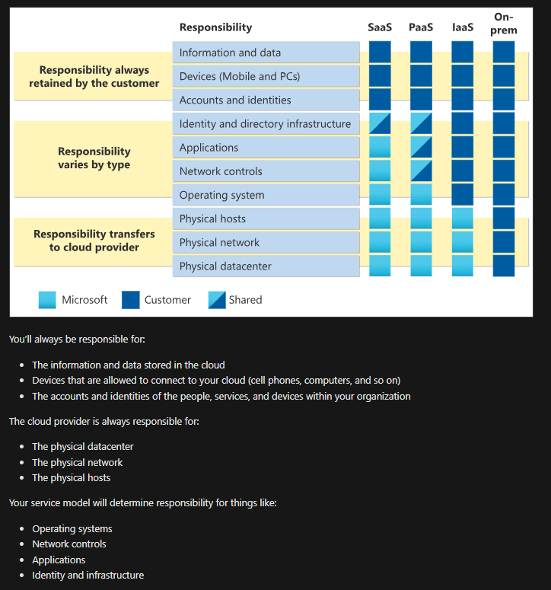

* Define cloud models :

Private Cloud : Dedicated computing environment used by a single organization (on prem or hosted by third party)

Public Cloud : Computing environment provided by third-party service provider and accessible to multiple organizations over the internet , owned by cloud service provider

Hybrid Cloud : Computing environment that uses both public and private clouds in an inter-connected environment, allowing data and applications to be shared between them.

Multi-cloud : In a multi-cloud environment you deal with two (or more) public cloud providers and manage resources and security in both environments.

Azure Arc : Azure Arc is a set of technologies that helps manage your cloud environment. Azure Arc can help manage your cloud environment, whether it's a public cloud solely on Azure, a private cloud in your datacenter, a hybrid configuration, or even a multi-cloud environment running on multiple cloud providers at once.

Azure VMware Solution : What if you’re already established with VMware in a private cloud environment but want to migrate to a public or hybrid cloud? Azure VMware Solution lets you run your VMware workloads in Azure with seamless integration and scalability.

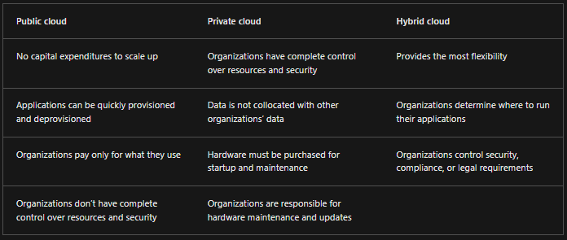

* Describe the consumption-based model : There are two types of expenses to consider. Capital expenditure (CapEx) and operational expenditure (OpEx).

CapEx is typically a one-time, up-front expenditure to purchase or secure tangible resources. A new building, repaving the parking lot, building a datacenter, or buying a company vehicle are examples of CapEx. In contrast, OpEx is spending money on services or products over time. Renting a convention center, leasing a company vehicle, or signing up for cloud services are all examples of OpEx.

Cloud Computing falls under the OpEx because cloud computing operates on a consumption-based mode. Consumption based model is youp ay for what you use. If you use more services , you will pay more.

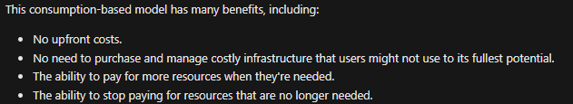

## Describe the benefits of using cloud services

* Describe the benefits of high availability and scalability in the cloud:

High Availability : SLA (Service Level agreement) is an agreement between the provider and the customer that states the percentage of availability of a service. The most common ones are 99%, 99,9% and 99,95% and these represents the uptime of the service which is the availability of the service. Higher uptime, more expensive.

Scalability : Scalability refers to the ability to adjust resources to meet demand. Scaling generally comes in two varieties: vertical and horizontal. Vertical scaling is focused on increasing (scaling up) or decreasing (scaling down) the capabilities of resources (RAM, CPU…) . Horizontal scaling is adding (scaling out) or subtracting (scaling in) the number of resources(Add more VM, containers…)

* Describe the benefits of reliability and predictability in the cloud :

Reliability : Reliability is the ability of a system to recover from failures and continue to function. The cloud with its decentralized design, naturally supports a reliable and resilient infrastructure. The cloud enables you to have resources deployed in regions around the world. Even if one region has a catastrophic event other regions are still up and running. You can design your applications to automatically take advantage of this increased reliability. In some cases, your cloud environment itself will automatically shift to a different region for you, with no action needed on your part

Predictability : Predictability in the cloud lets you move forward with confidence. Predictability can be focused on performance predictability or cost predictability. Deploy a solution that’s built around Azure framework and you have a solution whose cost and performance are predictable.

Performance : Performance predictability focuses on predicting the resources needed to deliver a positive experience for your customers. Autoscaling, load balancing, and high availability are just some of the cloud concepts that support performance predictability. If you suddenly need more resources, autoscaling can deploy additional resources to meet the demand, and then scale back when the demand drops. Or if the traffic is heavily focused on one area, load balancing will help redirect some of the overload to less stressed areas.

Cost : Cost predictability is focused on predicting or forecasting the cost of the cloud spend. With the cloud, you can track your resource use in real time, monitor resources to ensure that you’re using them in the most efficient way, and apply data analytics to find patterns and trends that help better plan resource deployments. By operating in the cloud and using cloud analytics and information, you can predict future costs and adjust your resources as needed. You can even use tools like the Total Cost of Ownership (TCO) or Pricing Calculator to get an estimate of potential cloud spend.

* Describe the benefits of security and governance in the cloud :

Using the cloud, whether for services or software, helps you follow rules and standards. Templates make sure everything you use meets company and government requirements. You can easily update everything to new rules. The cloud checks if anything doesn't follow the rules, and you can fix it. It can also automatically update software to keep things secure.

For security, choose a cloud option that fits what you need. If you want a lot of control, use infrastructure as a service. If you want things like patches and updates handled for you, go for platform as a service or software as a service. And because the cloud is intended as an over-the-internet delivery of IT resources, cloud providers are typically well suited to handle things like distributed denial of service (DDoS) attacks, making your network more robust and secure.

By establishing a good governance footprint early, you can keep your cloud footprint updated, secure, and well managed.

DDoS stands for Distributed Denial of Service. It's a type of cyber attack where multiple compromised computers, often part of a botnet (a network of infected computers controlled by a single entity), are used to flood a target system, service, or network with excessive traffic. The goal of a DDoS attack is to overwhelm the targeted resource, making it slow down or become completely unavailable to users.

* Describe the benefits of manageability in the cloud :

Two type of manageability :

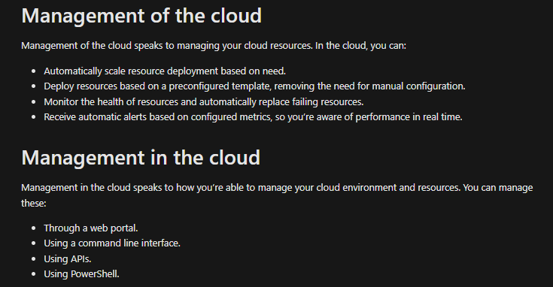

### Describe cloud service types

Kindly check the responsibilty model liste above too.

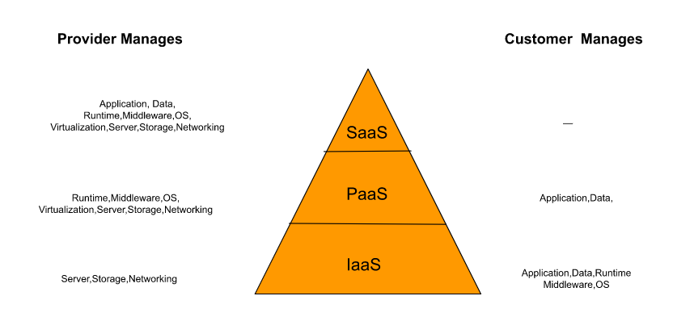

* Infrastructure as a Service :

Infrastructure as a service (IaaS) is the most flexible category of cloud services, as it provides you the maximum amount of control for your cloud resources. In an IaaS model, the cloud provider is responsible for maintaining the hardware, network connectivity (to the internet), and physical security. You’re responsible for everything else: operating system installation, configuration, and maintenance; network configuration; database and storage configuration; and so on. With IaaS, you’re essentially renting the hardware in a cloud datacenter, but what you do with that hardware is up to you.

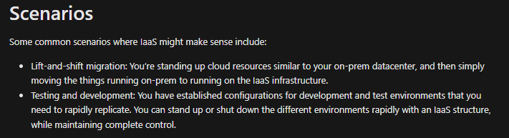

* Platform as a Service :

Platform as a service (PaaS) is a middle ground between renting space in a datacenter (infrastructure as a service) and paying for a complete and deployed solution (software as a service). In a PaaS environment, the cloud provider maintains the physical infrastructure, physical security, and connection to the internet. They also maintain the operating systems, middleware, development tools, and business intelligence services that make up a cloud solution. In a PaaS scenario, you don't have to worry about the licensing or patching for operating systems and databases.

PaaS is well suited to provide a complete development environment without the headache of maintaining all the development infrastructure.

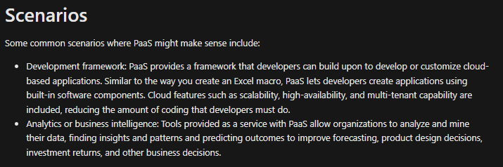

* Software as a Service :

Software as a service (SaaS) is the most complete cloud service model from a product perspective. With SaaS, you’re essentially renting or using a fully developed application. Email, financial software, messaging applications, and connectivity software are all common examples of a SaaS implementation.

While the SaaS model may be the least flexible, it’s also the easiest to get up and running. It requires the least amount of technical knowledge or expertise to fully employ.

